LEMBAR JAWAB ASESMEN SUMATIF AKHIR SEMESTER GASAL
TAHUN AJARAN 2025/2025

Nilai
Mata Pelajaran : Pendidikan Agama Islam
Kelas : V (Lima)
Nama Lengkap :
No. Peserta :

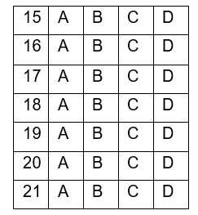
TP 1 TP 2 TP 3
1 | A | B | C | D
2 | A | B | C | D
3 | A | B | C | D
4 | A | B | C | D
5 | A | B | C | D
6 | A | B | C | D
7 | A | B | C | D
8 | A | B | C | D
9 | A | B | C | D
10 | A | B | C | D
11 | A | B | C | D
12 | A | B | C | D
13 | A | B | C | D
14 | A | B | C | D

TP 4 TP 5
22 | A | B | C | D
23 | A | B | C | D
24 | A | B | C | D
25 | A | B | C | D
26 | A | B | C | D
27 | A | B | C | D
28 | A | B | C | D
29 | A | B | C | D
30 | A | B | C | D
31 | A | B | C | D
32 | A | B | C | D
33 | A | B | C | D
34 | A | B | C | D
35 | A | B | C | D

URAIAN
36. …………………………………………………………………………………………………….
…………………………………………………………………………………………………….
37. …………………………………………………………………………………………………….
…………………………………………………………………………………………………….
38. …………………………………………………………………………………………………….
…………………………………………………………………………………………………….
39. …………………………………………………………………………………………………….
…………………………………………………………………………………………………….
40. …………………………………………………………………………………………………….
…………………………………………………………………………………………………….

